

International Technical Institute

(01-8270)

**Business Scenario**



**Business Scenario**

International Technical Institute is a private Registered Training Organisation (RTO). It comprises of five campuses geographically spread in South Australia. The main campus is based in the Adelaide City. Other Campuses are located at Mt Gambier, Noarlunga, Elizabeth, Port Pirie. It offers over 12 certificate and diploma level qualifications in the Vocational Education and Training (VET) sector for many subject areas including Business, Justice and IT and Community Services and Health.

Students go through the counselling process with a Lecturer to obtain a Study Plan. They have the option of studying On Campus. Students can select morning or afternoons classes. Some classes are self-directed in nature while others are Lecturer led and some Lecturers use a flipped classroom delivery style. With the self-directed courses Lecturers are available to handle student queries in class.

There are currently 250 students that attend the institute. Depending on their studies, students who require access to a computer are given access to Windows 10 desktop machine and all other applications software applicable to their studies plus access to the internet. The institute uses LEARN as a Learning Management System for access to all learning materials including the assessments.

The organisation is also growing in student numbers. However, they are not sure how large they will grow. Additionally, as the organisation grows, it would involve expanding IT costs.

Staff are based at multiple campuses and are often required to work in teams. However, working in teams has caused many frustrations amongst the staff when trying to connect and collaborate on a project. Staff have indicated that they would like to have access to more advanced productivity tools that facilitate better collaboration with their team members.

The current communication environment is hosted off-site by an external provider, BEAST IT. BEAST IT is hosting the current messaging (MS Exchange 2010) and document management systems (SharePoint 2010) for the organisation. BEAST IT have notified that the current contract is up for renewal. They have provided a tentative quotation for future hosting services.

However International Technical Institute has been unhappy with the providers services for a while as they have been unable to meet the organisation requirements. The service has been unstable and more recently there has been intermittent connection issues. Security has also become a challenge due to the changing threat and landscape and furthermore BEAST IT has not been able to meet the criteria to stay within compliance.  The organisation has to pay for all of the resources that are available, whether they are used or not, and has to invest in additional resources if use exceeds capacity. The hosted solution is not managed, and this means the organisation also has the responsibility for supporting the system.

International Technical Institute has decided not to extend the contract and would like to explore other options. Since the current environment is in quite a mess you have decided that you will ask BEAST IT to provide a backup of data but as the organisation doesn’t require data migration you will only use this when required and wish to start afresh with both systems.

International Technical Institute is looking for an improved solution to provide communication and collaboration services online. They also want the employees to be able create, share, and edit documents online making them accessible to all team members around the clock 24/7.

They have indicated that Microsoft is the preferred product they would like to implement as the required tool.

International Technical Institute has re-visited their Strategic Plan and their goals and have decided to update the objectives to meet the needs of the organisation. Based on the strategic goals and the updated objectives, the organisation would like to phase out the off-site hosted service and to implement online solution. This will provide a sustainable approach to teaching and learning, increased collaboration and to also allow for expansion throughout Australia.

**International Technical Institute** **Organisational structure**

IT Works has been hired by International Technical Institute to help with their ICT Project.

You work in the information technology department at IT Works. Your supervisor has tasked you to determine the best online Cloud solution for International Technical Institute.

Below is the current network diagram

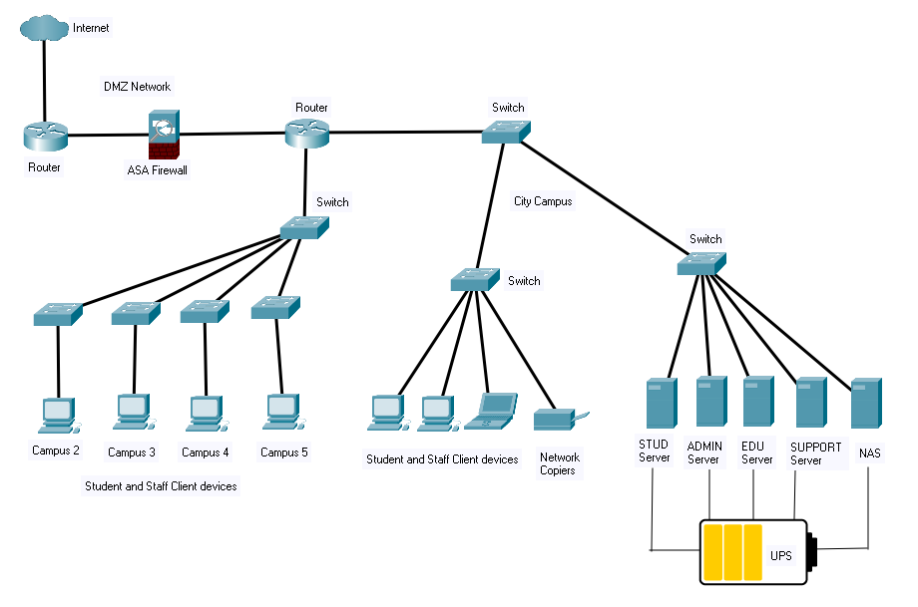

Com Hosted Off-site at BEAST IT

